CS251 Statistical Computing

**R installation for Windows**

2/19/2020 Developed by Aya

3/30/2020 Reviewed by Apiwat Chuaphan

Center for Information Assurance (CIAE) @City University of Seattle (CityU)

**Before You Start**

* If you already finished this module through any CityU Technology Institute (TI) courses,  
  just skim this module and skip it.
* Version numbers may not match with the guide. But that should be fine.  
  If given the option to choose between stable release (long-term support) or most recent, please choose the stable release.
* This guide targets Windows OS users. So, MacOS users may have different commands to input in the shell/terminal.
* We cannot explain every step. **This cookbook always needs your own creative judgement.**
* **For your working directory, use your course number.** The hands-on tutorial may use a different course number as an example.

**Learning Outcomes**

* Installing R for statistical project
* **Installing R for statistical project for Windows OS**

1. Visit <https://www.r-project.org/>
2. Choose **download R**

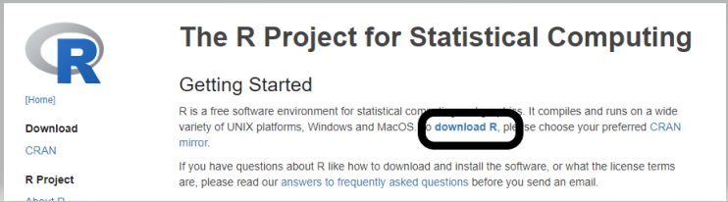

1. Scroll down to **USA** and click on the second link**.**

**If the second link isn’t working, try the third link.**

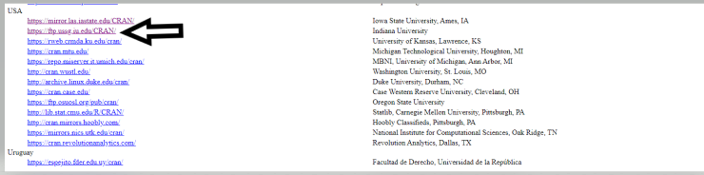

1. Select **Download R for windows**

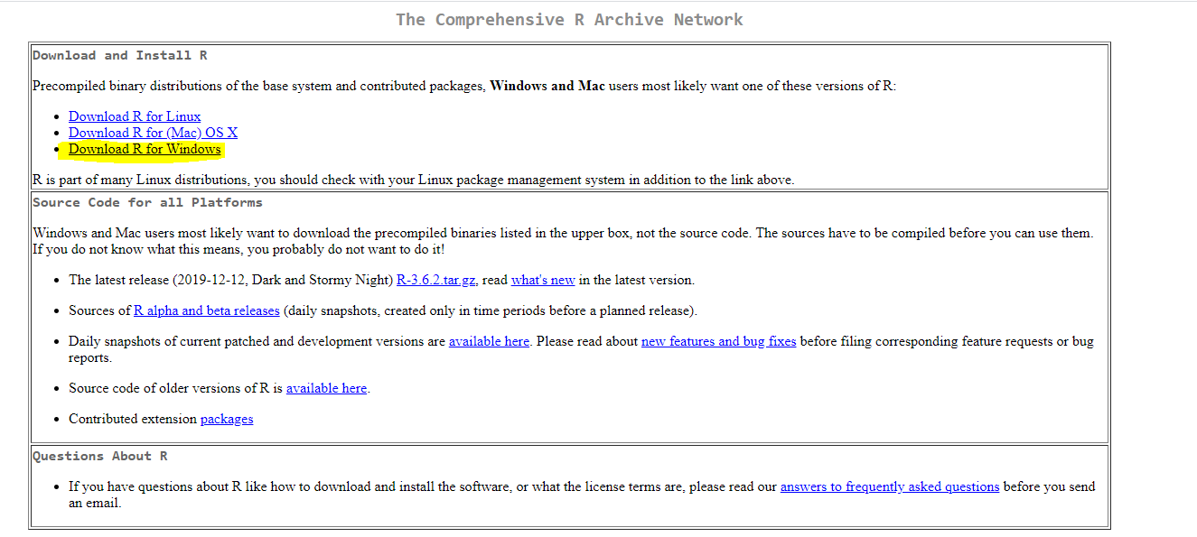

1. Open VScode and select extension, search for R, then install

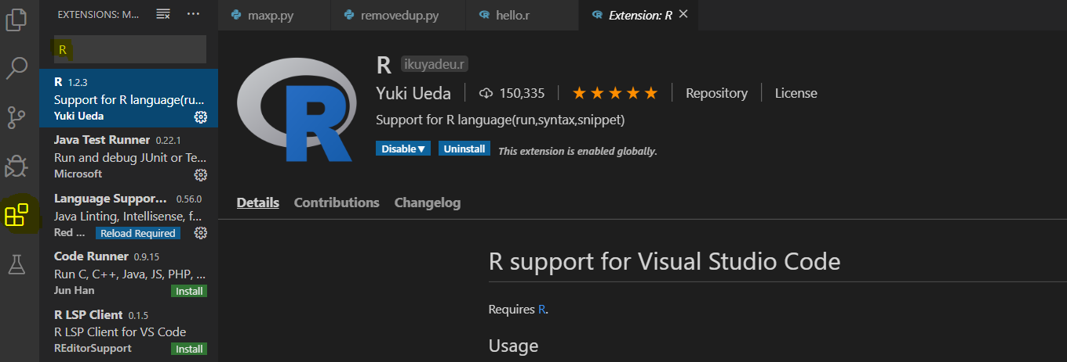

1. copy the path of your bin

* You can find in the place where you downloaded the R, usually it’s in Program Files. So, go to Program Files to make sure that you have the R folder there and copy the path of x64 in your bin
* Example, the yellow mark in the picture below is the path of x64 in my machine : C:\Program Files\R\R-3.6.2\bin\x64

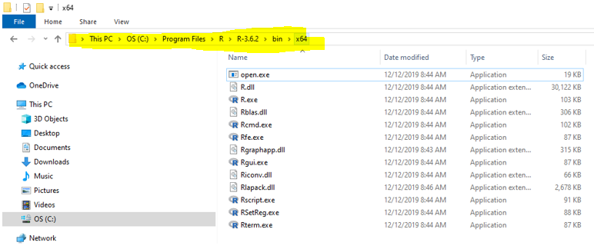

1. In the search box, type environment variables and select “**Edit the system environment variables**”

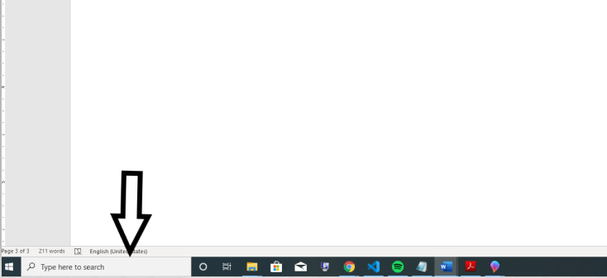

1. Select “Environment Variables”

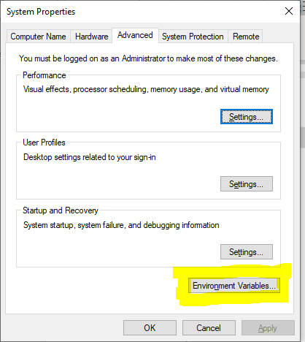

1. In “system variables” search for path Select edit

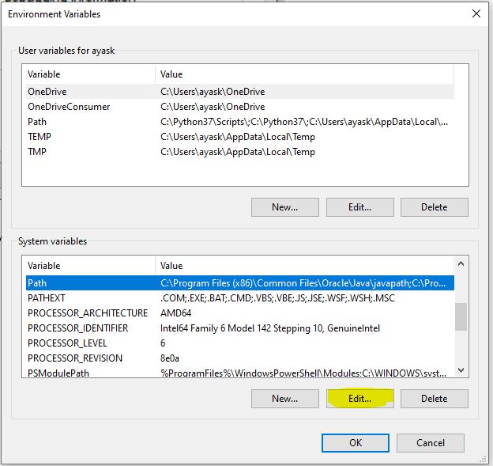

1. Select “New”, then paste the path of the bin

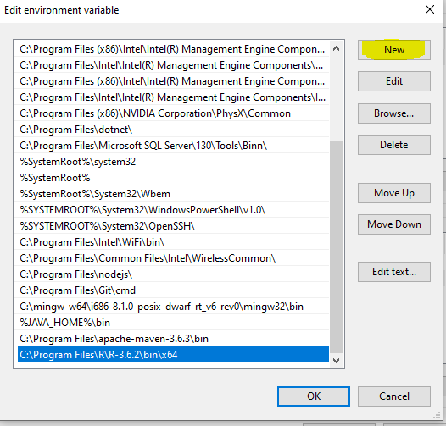

1. Open the cmd.
   * in the search bar type cmd and select Command Prompt.
2. type R to make sure that you installed the R correctly

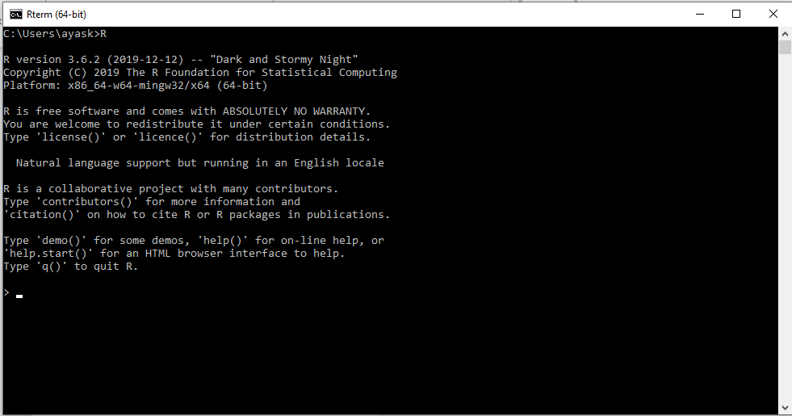

1. Open Vscode
2. Select file > preferences > settings

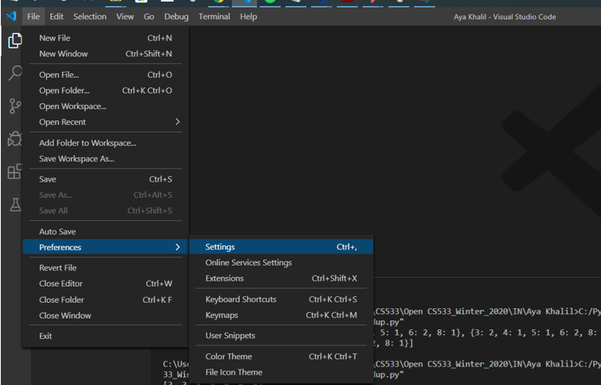

1. In extension, select r, then in “R.exe path for windows”

Add the path of the R.exe

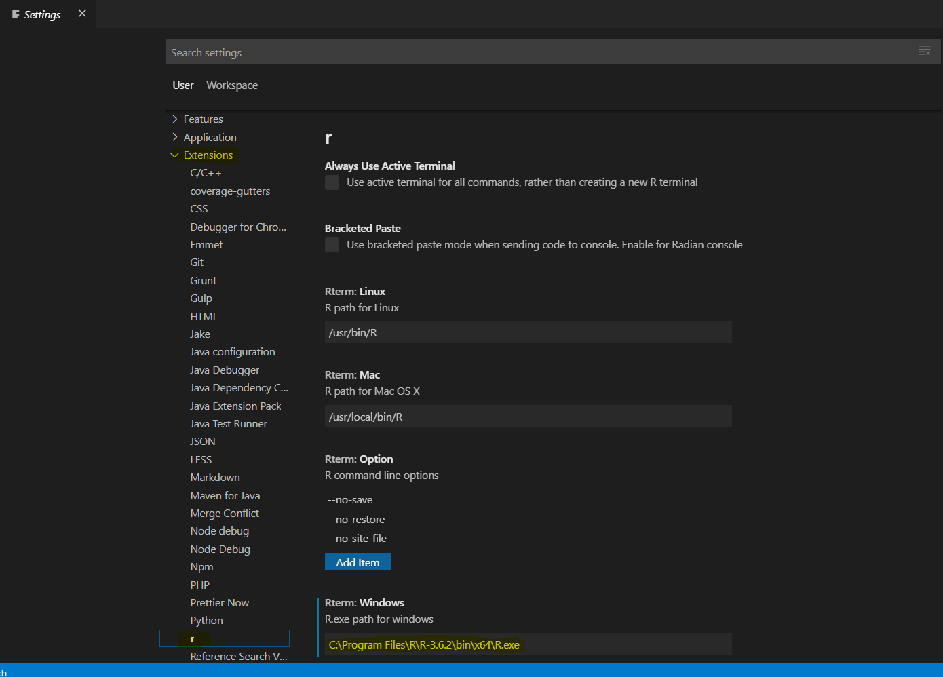

1. **Close the Vscode and open it again**

**Setup Working Environment for Module**

1. Open VS Code.
2. Go to your project folder

* **onsite student:** Open CS251_Fall_2020/**IN**/FirstnameLastname (file>open folder)
* **online student:** Open CS251_ Fall _2020/**ON**/FirstnameLastname (file > open folder)

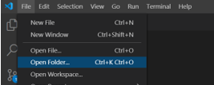

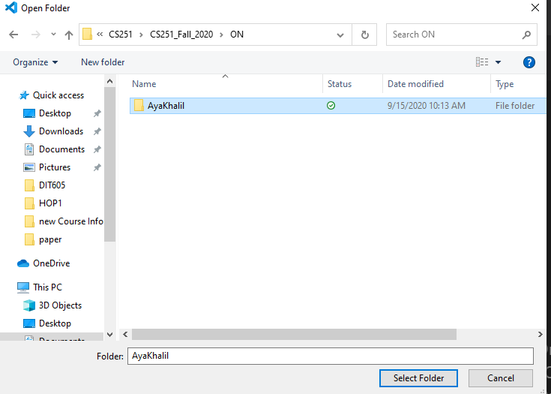

1. Then, in “**Module1**” directory in the VSCode.

* Right-Click on Module1 and select new file

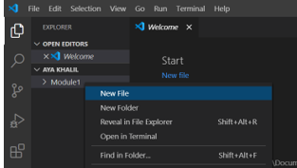

4)Create new file hello.R in Module1 project folder

-Write the following in hello.R file

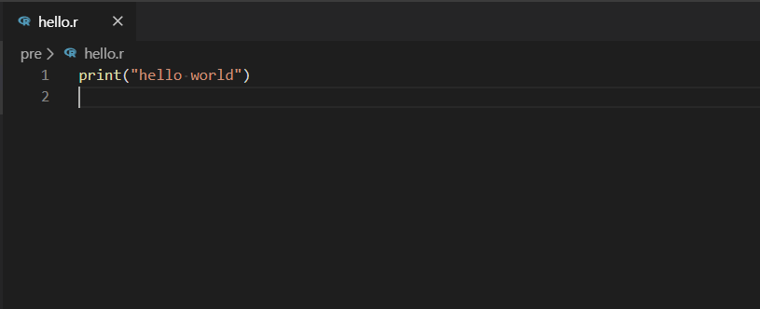

5)Don’t forget to save your file File>save or ctrl+s

6)To run your code press Run Source

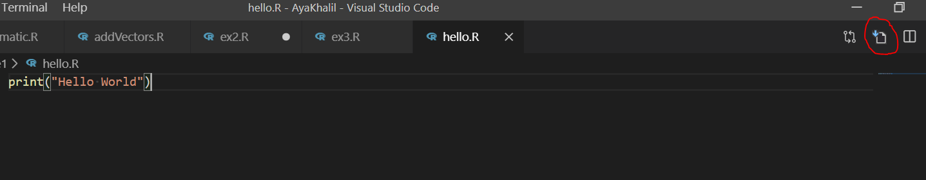

7) Your output should be:

